Make sure you consider the following:
- Compelling Introduction that hooks the reader. Engaging writing to sustain the reader’s interest throughout.
- The topic must be focused narrowly enough for the scope of this assignment.
- A position thesis statement provides direction for the paper.
- The subtopics should flow together and not be all over the place. The ideas are arranged logically to support the central purpose. They are usually clearly linked to each other. For the most part, the reader can follow the line of reasoning.
- For each of your subheadings make sure your writing is clear and concise. It is important not to become sidetracked. Effective use of coordination, subordination, division and parallelism
- References are primarily peer reviewed professional journals or other approved sources (e.g., government documents, agency manuals, and organizations’ websites). The reader is confident that the information and ideas can be trusted.
- The evidence comes from a wide variety of valid sources. The bibliography is complete and reflects appropriate sources.
- Sources are exceptionally well integrated and they support claims argued in the paper very effectively.
Look at the types of thesis you could use.
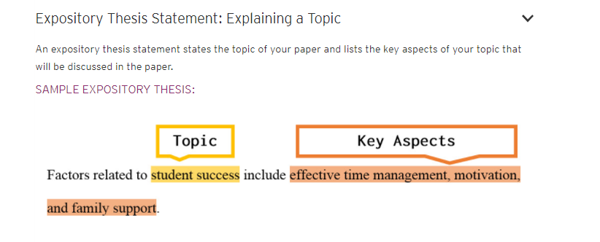
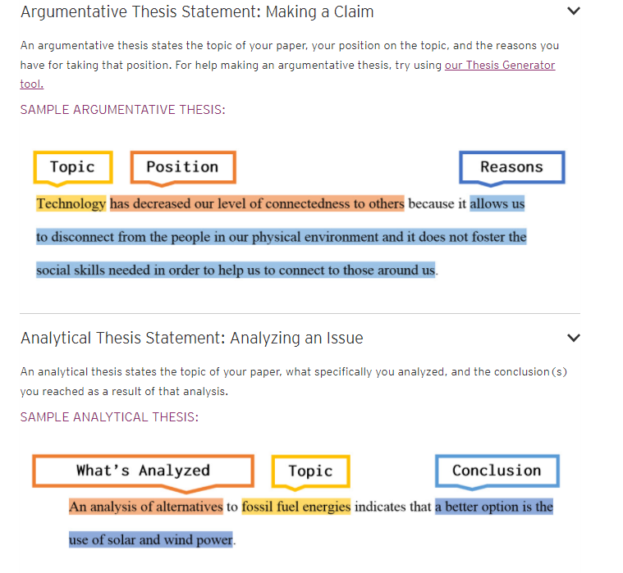

Here is what you should consider when writing an introduction.
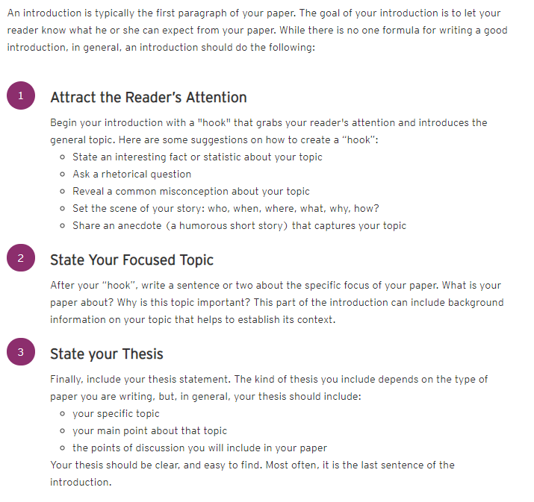

- Sentences are well-phrased and varied in length and structure. They flow smoothly from one to another.
- Compelling evidence from professionally legitimate sources is given to support claims. Attribution is clear and fairly represented. Quotations from others outweigh the writer’s own ideas excessively.
- The content of the paper should have a balanced presentation of relevant, accurate and legitimate information that is offered in clear support of the central purpose of the argument that you are presenting. This should also show thoughtful and in-depth analysis of the topic you are researching. Effective, smooth, and logical transitions
- The conclusions reached should be well supported by the body of your work It is essential to check that the conclusions, questions raised or suggested solutions are strongly supported within the report.

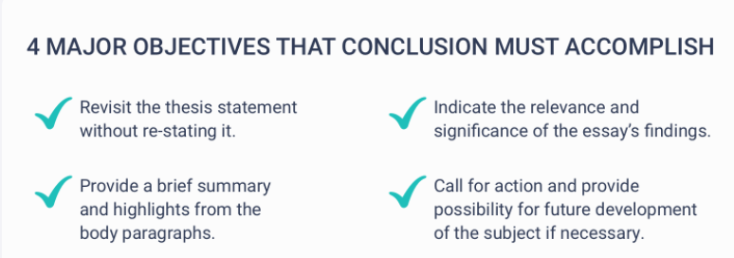

My three favorite websites:
https://writingcenter.ashford.edu/writing-a-thesis argumentative, analytical or expository.
https://writingcenter.ashford.edu/introductions-conclusions
https://essaypro.com/blog/how-to-write-a-conclusion

Other websites to check out when writing the conclusion:

https://writingcenter.fas.harvard.edu/pages/developing-thesis
https://writing.wisc.edu/handbook/process/thesis_or_purpose/
https://bid4papers.com/blog/essay-conclusion/
https://www.indeed.com/career-advice/career-development/how-to-write-a-conclusion-for-a-research-paper
https://grammar.yourdictionary.com/grammar/writing/how-to-write-a-conclusion.html
https://academicguides.waldenu.edu/writingcenter/writingprocess/conclusions

